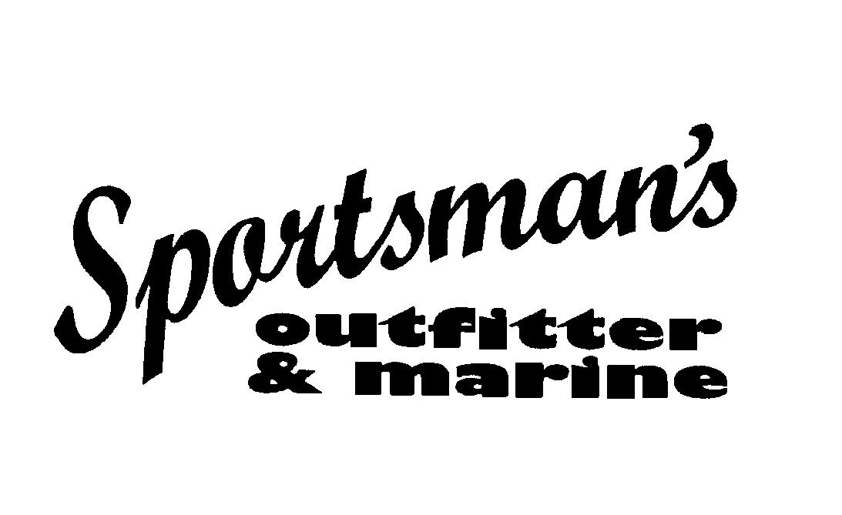
 19700 South Peculiar Drive

Storage Lease Agreement by and between:

Lessee: and Sportsman's Outfitter & Marine, Inc.

19700 South Peculiar Drive - Belton, MO 64012

(816) 524 – 2277 info@somkc.com

( ) - hm/wk/cell

( ) - hm/wk/cell Valid email address:________________________________________

LESSEE: The “Lessee” shall be the person(s) whom have ownership, legal right, and title to the unit intended for storage.
LESSOR: The “Lessor” (hereafter referred to as Sportsman’s) shall be defined as the entity charged with the storage of the unit.

Commence Date: ______________ 6 Month:_____________ 60 Days: ______________ MTM ( ) Gate Code: Space #

Unit description:____________________________________________________________________________________________________

Insurance Provider, Policy #, Agent, Phone #:

FEES and TERM: Move in rate will be initially set at $75 per month for a 12 month contract term resulting in a total of $900 annually. All storage fees must be pre-paid, No monthly invoices will be distributed by Sportsman's. On a case by case basis a month-to-month arrangement may be offered at a higher rate, currently set at $119 per month. No deviation from the standard programs will be recognized without written agreement signed by both parties stating otherwise. Annual contracts will not automatically renew at the special rate, however be it known that upon completion of the term of this agreement, Sportsman’s intends to offer current Lessees in good standing the right of first renewal to keep their current spot (or change to another space if available) at a rate to be determined at that time.

TERMINATION: This agreement will expire on the 12 month anniversary of the Commence Date above. Either party may terminate the storage contract at any time, prorated refunds of fees will be based on the date of the unit being removed, and issued per the following schedule:
Greater than 6 months remaining: $300 refund / 6 months or less remaining: $100 refund / No refund during final 90 days of term
Refunds will be paid via company check and mailed to the Lessee address above and postmarked within 10 days of the removal of unit. Failure to comply with any provision contained herein could result in termination of the agreement requiring immediate removal of unit with no refund.

LIABILITY: Lessee acknowledges that they have inspected the premises and are satisfied that the premises are adequate for the safe storage of Lessee’s unit. Sportsman’s insurance coverage specifically excludes any and all coverage of any and all units on our property that we do not own. Lessee hereby agrees to maintain their own comprehensive and liability insurance or other form of coverage or be held personally liable for the unit described above and its contents. Lessee further agrees that Sportsman's, its affiliates, employees, and/or owners will not be held liable for any damages to or loss of the unit(s) described above and their contents due to fire, flood, vandalism, accident, theft, or any other event or act of God that may cause damage to or loss of any units or contents described herein. Further, the Lessee also is advised to remove all electronics, personal items, fuel tanks, or any accessory that could be easily removed from the unit and retain those in their personal custody if they so desire. It is also advised that no food, wrappers, beverages, containers, or residue of the same remain in the unit as we explicitly will not be responsible for infestations of or damage caused by birds, insects, rodents, or other animals. If shrink wrapped by us, Sportsman's makes every effort to fully dry the interior of all stored units before they are wrapped, and dehumidifiers are placed inside every unit that we wrap. This will retard - but nothing can fully prevent - mold, mildew, etc. and Sportsman's will not be responsible for residue of or stains caused by mold, mildew, or other conditions perceived to have been caused by the same.

HOLD HARMLESS: Lessee shall fully defend, indemnify, and hold harmless Sportsman’s Outfitter & Marine, Inc. from any and all claims, lawsuits, demands, causes of action, liability, loss, damage and/or injury, of any kind whatsoever (including without limitation all claims for monetary loss, property damage, equitable relief, personal injury and/or wrongful death), whether brought by an individual or other entity, or imposed by a court of law or by administrative action of any federal, state, or local governmental body or agency, arising out of, in any way whatsoever, any acts, omissions, negligence, or willful misconduct on the part of Sportsman’s, its officers, owners, personnel, employees, agents, contractors, invitees, or volunteers. This indemnification applies to and includes, without limitation, the payment of all penalties, fines, judgments, awards, decrees, attorneys' fees, and related costs or expenses, and any reimbursements to Sportsman’s for all legal fees, expenses, and costs incurred by it.

DESIGNATED SPACE: All interests and privileges of the Lessee created under this agreement shall apply only to the particular space designated to the Lessee by Sportsman’s and further defined herein. Effort will be made to accommodate Lessee requests, however no space is to be considered guaranteed. Location can be changed within the facility at the sole discretion of Sportsman’s. This agreement is not transferable or assignable to any other party or unit. Written permission and amendment of this agreement will be required for Lessee to change places or to change the unit stored in the designated space. The unit stored by Lessee shall be subject to approval by Sportsman’s for fitness and suitability standards. Special arrangements outside this agreement will be necessary for units with a length greater than 40’ and/or a width greater than 102”. Spaces will be defined by a low profile parking barrier and will be clearly marked with the space number and set by Sportsman’s in accordance with the length of the unit to be stored and is not to be moved by Lessee. The designated space will then be considered a rectangular area equal to the length and width of the unit stored measured at its longest and widest points, once parked as directed by Sportsman’s. This footprint will be considered the designated space and all area outside of that footprint will be considered common area that must be left clear and unobstructed. Unit must be perpendicular to the barrier and backed up until rear wheels securely rest against the barrier. Unit wheels must then be chocked by two (2) approved wheel chocks to prevent any possible shifting before parking the unit. If unit does not have a jack stand or stands equipped with weight distributing feet or pads on them (for example the unit has a dolly wheel or roller), then an approved disc or plate with a minimum diameter or length and width of 6” or more shall be placed under the same to help distribute the weight and minimize sinking. All units must be parked correctly in the designated space, units that are not parked correctly or are parked in another space will be moved or towed back to the designated space and the cost of moving or towing (including lock removal if applicable) shall be billed to and immediately due from the Lessee. Failure to park correctly in designated spot or failure to comply with these provisions could result in Lessee being responsible for facility or unit repairs, as well as potential additional moving or towing costs and fees.

SECURITY: Lessee will be issued a unique random code that allows continuous and uninterrupted access 24 hours a day and 7 days per week to the facility with no holiday or other closures planned or intended. This code operates the automatic gate in both directions and is not transferrable and should not be shared with other parties. Lessee could be held liable for actions taken or lack thereof attributable to access associated with Lessee’s private code. Lessee’s unique security code can be changed at any time at the discretion of Sportsman’s and notification will be made of the same. If Lessee feels their code may have been compromised, a replacement code will be issued upon request. Security cameras and a monitored alarm system are in place. Lessee agrees to reasonably comply with Law Enforcement investigations and requests. Sportsman’s will grant Law Enforcement reasonable requests to access video footage, and Lessee by entering into this agreement grants consent to be videotaped and otherwise monitored while on premises. Please be courteous and conscientious of others at all times, and if you accidentally damage a neighbor’s unit, please report it to Sportsman’s representatives so notification can be made. Reparations and disputes are between individual Lessees of the spaces only, and beyond reasonable cooperation Sportsman’s will not be involved in the same. The facilities are not continuously monitored by Sportsman’s either in person or on video and should not be considered as such. Sportsman’s has made a diligent effort to secure premises from theft or damage to units stored but it shall be the responsibility of the Lessee to insure, at their own expense, the property stored on the premises against said losses. A tongue or hitch lock is not required or even recommended but ultimately is the right of the Lessee to use. If Lessee chooses to utilize a hitch lock, then a spare key to the same shall be clearly labeled with owner’s name and designated space number and left with Sportsman’s.

HAZARDOUS MATERIALS AND OTHER RESTRICTIONS: No materials classified as explosive, hazardous, or toxic shall be stored on site. Batteries must be left in designated place(s) inside the units and may not be left on the ground. Outside of normal fuel in approved onboard or built in tanks, no fuel or other hazardous materials are to be stored in the space. All waste holding tanks or port-a pots must be emptied at a proper dumping facility before being brought to the space. Lessee agrees not to store or cause to be stored any dangerous or leaking units in the designated space. Lessee shall not use the storage space for any unlawful purpose, conduct any type of business from, and no persons or animals shall remain in units while stored, i.e. no overnight camping is allowed. Breach of these requirements could result in remedy costs being charged to Lessee to clean and restore entire affected area and any neighboring units to prior condition, and any other remedy permitted by law.

FACILITY MAINTENANCE: Sportsman’s will make reasonable efforts to keep the facility free of obstructions that may hinder access to the property stored on site. Specific exception is hereby declared and made known for the removal of snow from the grounds, no plowing of snow will be done or is allowed inside the facility. The inspection of units, and the clearing, draining, or raking of covers shall be the sole responsibility of the Lessee. Sportsman’s shall have the right to move units stored for purposes of maintenance of the unit or the facility but assumes no responsibility for tending to any unit stored. Sportsman’s will make reasonable efforts to contact and notify Lessee of dangerous conditions requiring Lessee’s attention, but the above stated notification shall be considered gratis by the Lessee and is no part of the consideration given herein and Sportsman’s assumes no responsibility for the dangerous conditions, its attendant results, or for the failure to notify of any such condition. Acts of God, power outages, mechanical failure, and weather or other natural events that hinder or prevent access to the units stored will be remedied at the earliest reasonable opportunity and no reparations will be made or considered due to lack of or delayed access.

NO BAILMENT: Lessee acknowledges that Sportsman’s does not have exclusive possession and/or control of the units stored, which is shared with the Lessee during the term of this agreement. Lessee agrees they have reasonable access to the unit. Custody, control, and possession are not transferred. This agreement does not constitute a bailment for any specific purpose.

WORK: No work is allowed to be performed on the units inside the storage area other than by Sportsman’s personnel or their authorized contractors and subcontractors without permission. Sportsman’s is a Mercury/Mercruiser authorized service center, and marine service within the scope of our capabilities will be available “hands free” with a call to our service department. For elective work, the unit will be moved from the storage lot to the shop and back at no charge. Winterization on all brands of marine engines is offered by Sportsman’s for boats and PWC. Shrink wrap is also available, along with detailing and a host of other services. Please inquire for further details.

DISPOSITION OF EQUIPMENT: At the end of the contract term, in the absence of a renewal or other arrangements being made, Sportsman’s reserves the right to dispose of in any way it sees fit, up to and including a commercially reasonable forced sale, any unit or contents that have been abandoned after a reasonable attempt has been made to contact and/or locate the owner. Disposal costs are the Lessee’s responsibility.

ACCEPTANCE OF AGREEMENT: Storage and/or payment for storage in any form constitutes acceptance of the terms and conditions as set forth by this agreement whether the original document is signed by the actual owner of said unit or not. Should any term or condition of this agreement be held void or unenforceable, then that term shall be deemed narrowed or severed and the enforceability of the remainder of this agreement shall not be affected and will remain in full force and effect. I/we have read the above agreement thoroughly and by affixing my/our signature(s) below, affirm that I/we agree to any and all terms and conditions contained herein and were provided a photocopy of the same.

Lessee Signature(s): Date:

Authorized agent for Sportsman's Outfitter & Marine: _____________________ Date:

